How to view threads of a process on linuxand thread programm

Objectives:
- What is Thread.
- Types of Thread
- Implementation of Thread
Theory: A thread is a flow of execution through the process code, with its own program counter that keeps track of which instruction to execute next, system registers which hold its current working variables, and a stack which contains the execution history.
A thread shares with its peer threads few information like code segment, data segment and open files. When one thread alters a code segment memory item, all other threads see that.
A thread is also called a lightweight process. Threads provide a way to improve application performance through parallelism. Threads represent a software approach to improving performance of operating system by reducing the overhead thread is equivalent to a classical process.

Types of Thread:
Threads are implemented in following two ways −
- User Level Threads − User managed threads.
- Kernel Level Threads − Operating System managed threads acting on kernel, an operating system core.

Multithreading Models:
Some operating system provide a combined user level thread and Kernel level thread facility. Solaris is a good example of this combined approach. In a combined system, multiple threads within the same application can run in parallel on multiple processors and a blocking system call need not block the entire process. Multithreading models are three types
- Many to many relationship.
- Many to one relationship.
- One to one relationship.

Corresponding Code:
#include<stdio.h>
#include<string.h>
#include<pthread.h>
#include<stdlib.h>
#include<unistd.h>

pthread_t tid[2];

void* doSomeThing(void *arg)
{
unsigned long i = 0;
pthread_t id = pthread_self();

if(pthread_equal(id,tid[0]))
{
printf("\n First thread processing\n");
}
else
{
printf("\n Second thread processing\n");
}

for(i=0; i<(0xFFFFFFFF);i++);

return NULL;
}

int main(void)
{
int i = 0;
int err;

while(i < 2)
{
err = pthread_create(&(tid[i]), NULL, &doSomeThing, NULL);
if (err != 0)
printf("\ncan't create thread :[%s]", strerror(err));
else
printf("\n Thread created successfully\n");

i++;
}

sleep(5);
return 0;
}

Output:

Thread in command line:
Here are several ways to show threads for a process on Linux.

1: PS
In ps command, "-T" option enables thread views. The following command list all threads created by a process with <pid>
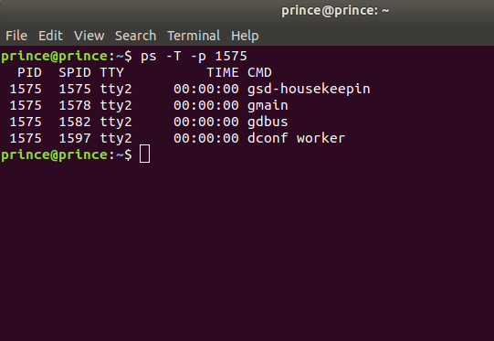
The "SID" column represents thread IDs, and "CMD" column shows thread names.

2: Top:

The top command can show a real-time view of individual threads. To enable thread views in the top output, invoke top with "-H" option. This will list all Linux threads.
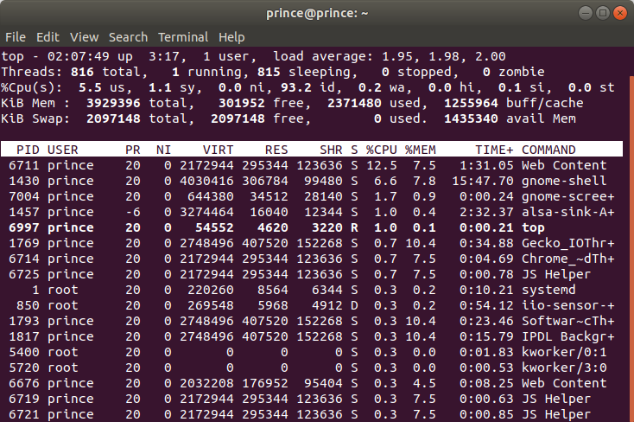
To restrict the top output to a particular process <pid> and check all threads running inside the process: then we use
$ top -H -p <pid>
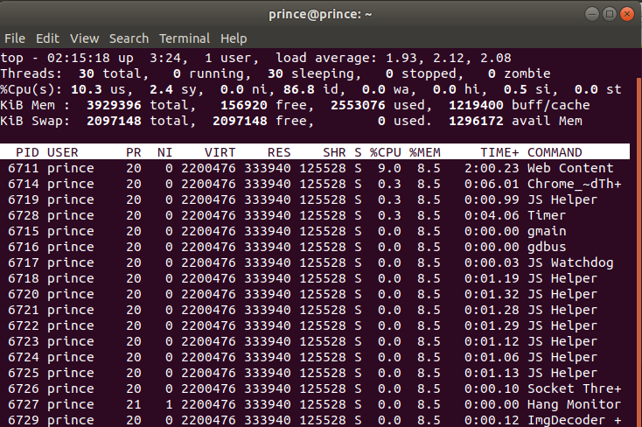

3: Htop:

A more user-friendly way to view threads per process is via htop, an ncurses-based interactive process viewer. This program allows you to monitor individual threads in tree views.

